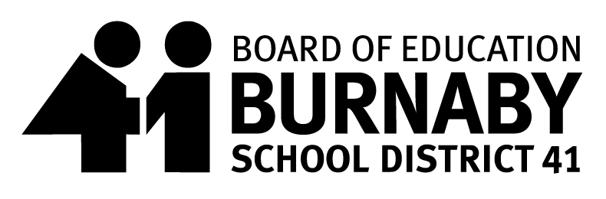
SCHOOL MEAL PROGRAM
Hot Lunch Menu Date: Sept.4th – 27th 2024
Thank you for supporting the School Meal Program

Monday | Tuesday | Wednesday | Thursday | Friday
2  Labour Day  No School | 3  First Day Back to School  No Hot Lunch | 4  Turkey Hot Dog  Veggie Hot Dog | 5  Chicken Fried Rice / Mini Spring Roll  Veggie Fried Rice with Egg / Mini Spring Roll | 6  French Toast & Yogurt
9  Twist and Shout Rotini  Same for Veggie option | 10  Cheese Burger Pasta  Veggie Cheese Burg’r Pasta | 11  Lasagna with Ground Beef & Cheese  Vegetarian Lasagna | 12  Teriyaki Chicken Chowmein  Veggie Teriyaki Chick’n Chowmein | 13  SUBWAY
16  Meatball Tater Tot Poutine with Gravy  Veggie Meatball Tater Tot Poutine with Gravy | 17  Chicken Burger  Veggie Chick’N Burger | 18  Sweet & Sour Chicken with Rice  Sweet & Sour Veggie Chick’N with Rice | 19  Macaroni and Cheese  Same for Veggie option | 20  Pancakes with Yogurt Tubes  Same for Veggie option
23  Spaghetti Bolognese with Meatsauce  Spaghetti Veggie Ground Bolognese | 24  DIY Chicken Finger Wrap  DIY Veggie Chick’n Wrap | 25  Chicken Nuggets & Hashbrowns  Veggie Chick’n Nuggets & Hashbrowns | 26  Butter Chicken with Rice  Butter Chickpeas with Rice | 27  PIZZA
All Meals include Fruit or Veggie and a small milk

