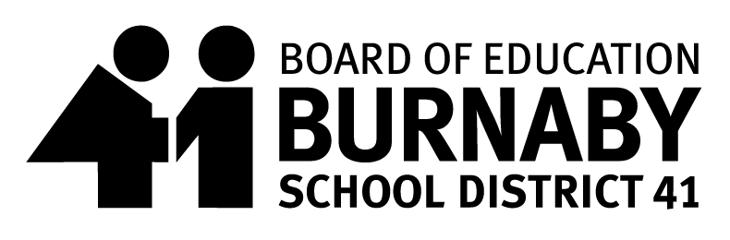
SCHOOL MEAL PROGRAM
Hot Lunch Menu Date: Sept.30th – Oct.25th 2024
Thank you for supporting the School Meal Program

Monday | Tuesday | Wednesday | Thursday | Friday
30  National Day for Truth & Reconciliation  STAT HOLIDAY | 1  Macaroni and Cheese | 2  French Toast  & Yogurt | 3  Sweet & Sour Chicken ChowMein  Sweet & Sour Veggie Chick’N ChowMein | 4  Beef Meatball Submarine  Veggie Meatball Submarine
7  Penne Alfredo  (New) | 8  Chicken Nuggets & Hashbrowns Triangles  Veggie Chick’n Nuggets & Hashbrowns Triangles | 9  Lasagna with Ground Beef & Cheese  Vegetarian Lasagna | 10  Kid Friendly Butter Chicken with Rice  Butter Chickpeas with Rice | 11  PIZZA
14  ThanksGiving  STAT HOLIDAY | 15  Teriyaki Chicken Chowmein  Teriyaki Chick’N ChowMein | 16  Cheesy Pizza Plank (New)  Same for Veggie option | 17  BBQ Meatballs with Mashed Potatoes  Veggie Meatballs with Mashed Potatoes | 18  Cheeseburger Pasta  Veggie Cheeseburger Pasta
21  DIY Chicken Finger Wrap  DIY Veggie Chick’n Wrap | 22  Meatball Tater Tot Poutine with Brown Gravy  Veggie Meatball Tater Tot Poutine with Brown Gravy | 23  Chicken Burger  Veggie Chick’N Burger | 24  Twist & Shout Rotini in Tomato Sauce  Same for Veggie option | 25  DISTRICT  PRO-D Day
All Meals include Fruit or Veggie and a small milk

