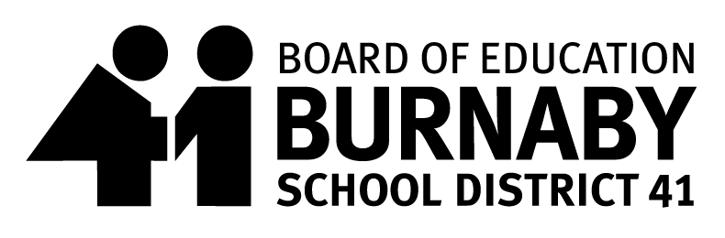
SCHOOL MEAL PROGRAM
Hot Lunch Menu Date: Oct.28th – Nov.22nd 2024
Thank you for supporting the School Meal Program

Monday | Tuesday | Wednesday | Thursday | Friday
28  Pancakes with Yogurt Tube | 29  BBQ Chicken Drumstick with Rice  Veggie BBQ Nuggets with Rice | 30  Cheeseburger Pasta  Veggie Cheeseburger Pasta | 31  Chicken Burger  Veggie Burger | 01  SUBWAY
04  Macaroni & Cheese | 05  Sweet & Sour Chicken Chowmein  Sweet & Sour Tofu Chowmein | 06  Beef Meatball Tater Tot Poutine  Veggie Tater Tot Poutine | 07  Topsy Turvy Pasta  Veggie Topsy Turvy Pasta | 08  French Toast with Yogurt Tube
11  Remembrance Day  No School | 12  Spaghetti & Meatsauce  Spaghetti & Veggie Meatsauce | 13  Turkey Hot Dog  Veggie Hot Dog | 14  Teriyaki Chicken Rice Bowl  Teriyaki Veggie Rice Bowl | 15  PIZZA
18  Kid Friendly Butter Chicken with Rice  Butter Chickpeas with Rice | 19  Chicken Swarma Wrap  Falafel Shawarma Wrap | 20  Beef Taco Mix  Tortilla Chips  Sour Cream  Veggie Taco Mix  Tortilla Chips  Sour Cream | 21  Chicken Fried Rice with Spring Roll  Veggie Fried Rice  Spring Roll | 22  District Pro-D  Day
All Meals include Fruit or Veggie and a small milk

